Chapter 06
Efficient Diversification

- So long as the correlation coefficient is neither zero nor 1.0, the portfolio will contain diversification benefits. Any other combination will cause a diversification benefit since the standard deviation will fall, relative to the return on the portfolio. Otherwise, the risk and return will change in unison.

- The covariance with the other assets is more important. Diversification is accomplished via correlation with other assets. Covariance helps determine that number.

- a. and b. will both have the same impact of increasing the sharpe measure from .40 to .45.

- The expected return of the portfolio will be impacted if the asset allocation is changed. Since the expected return of the portfolio is the first item in the numerator of the sharpe ratio, the ratio will be changed.

- Impact on total variance
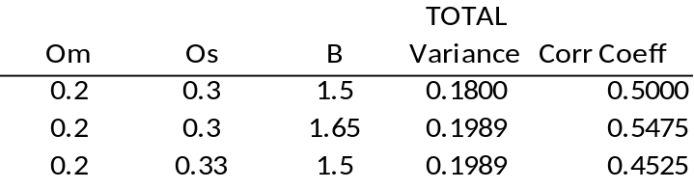

a. Both will have the same impact. The total variance will increase from .18 to .1989
b. An increase in beta, however, increases the correlation coefficient and thus creates more diversification benefit.

  - Without doing any math, the severe recession is worse and the boom is better. Thus, there appears to be a higher variance, yet the mean is probably the same since the spread is equally larger on both the high and low side. The mean return, however, should be higher since there is higher probability given to the higher returns.

  - Calculation of mean return and variance for the stock fund:

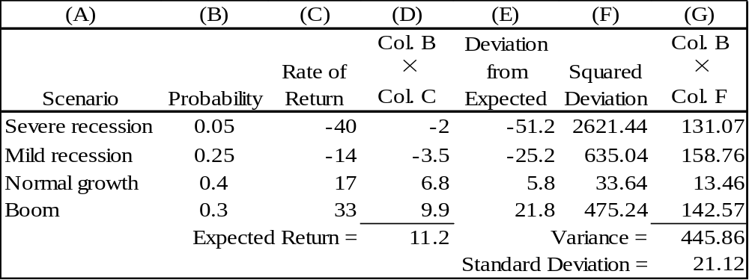

  - Calculation of covariance:
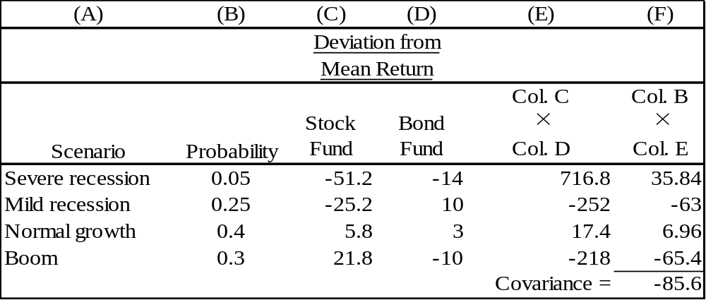

Covariance has increased because the stock returns are more extreme in the recession and boom periods. This makes the tendency for stock returns to be poor when bond returns are good (and vice versa) even more dramatic.

  - One would expect variance to increase because the probabilities of the extreme outcomes are now higher.

  - Calculation of mean return and variance for the stock fund:
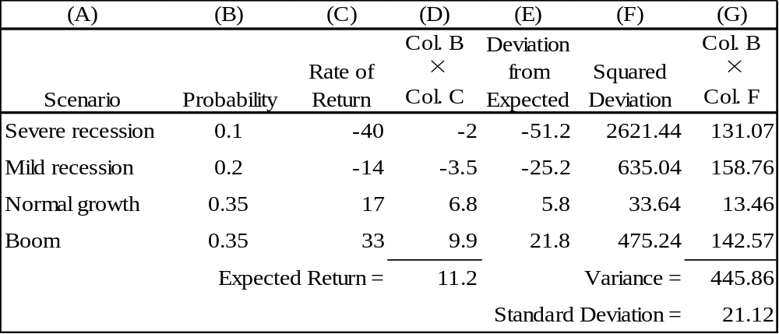

  - Calculation of covariance
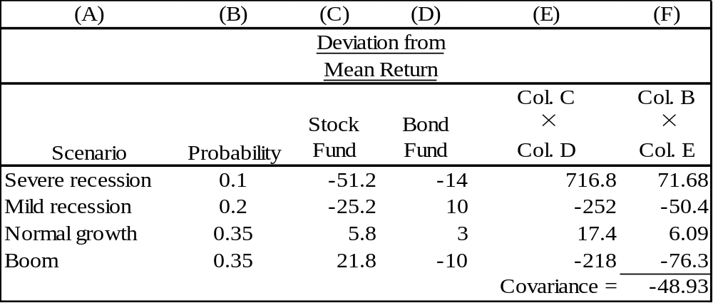

Covariance has decreased because the probabilities of the more extreme returns in the recession and boom periods are now higher. This gives more weight to the extremes in the mean calculation, thus making their deviation from the mean less pronounced.

- The parameters of the opportunity set are:
E(r_{S}) = 15%, E(r_{B}) = 9%, σ_{S} = 32%, σ_{B} = 23%, ρ = 0.15, r_{f} = 5.5%
From the standard deviations and the correlation coefficient we generate the covariance matrix [note that Cov(r_{S}, r_{B}) = ρσ_{S}σ_{B}]:
 | Bonds | Stocks
Bonds | 529.0 | 110.4
Stocks | 110.4 | 1024.0

The minimum-variance portfolio proportions are:
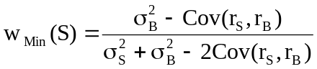
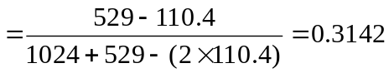
w_{Min}(B) = 0.6858

The mean and standard deviation of the minimum variance portfolio are:
E(r_{Min}) = (0.3142 × 15%) + (0.6858 × 9%) = 10.89%
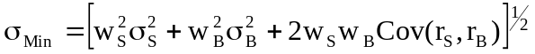
= [(0.3142² × 1024) + (0.6858² × 529) + (2 × 0.3142 × 0.6858 × 110.4)]1/2
= 19.94%

% in stocks | % in bonds | Exp. return | Std dev.
00.00 | 100.00 | 9.00 | 23.00
20.00 | 80.00 | 10.20 | 20.37
31.42 | 68.58 | 10.89 | 19.94 | Minimum variance
40.00 | 60.00 | 11.40 | 20.18
60.00 | 40.00 | 12.60 | 22.50
70.75 | 29.25 | 13.25 | 24.57 | Tangency portfolio
80.00 | 20.00 | 13.80 | 26.68
100.00 | 00.00 | 15.00 | 32.00

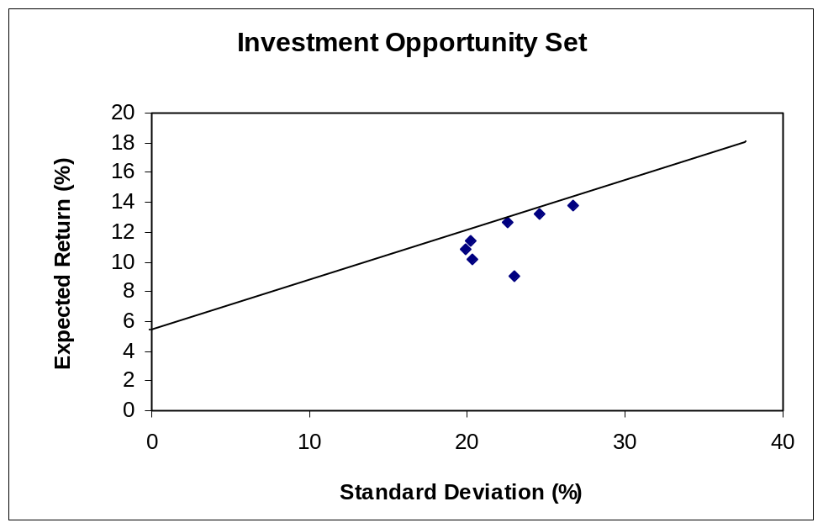

The graph approximates the points:
 | E(r) | σ
Minimum Variance Portfolio | 10.89% | 19.94%
Tangency Portfolio | 13.25% | 24.57%

- The reward-to-variability ratio of the optimal CAL is:
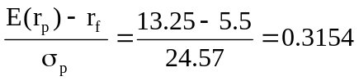

  - The equation for the CAL is:
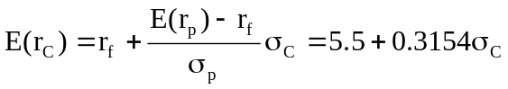
Setting E(rC) equal to 12% yields a standard deviation of: 20.61%

  - The mean of the complete portfolio as a function of the proportion invested in the risky portfolio (y) is:

E(r_{C}) = (l − y)r_{f} + yE(r_{P}) = r_{f} + y[E(r_{P}) − r_{f}] = 5.5 + y(13.25− 5.5)

Setting E(r_{C}) = 12% ⇒ y = 0.8387 (83.87% in the risky portfolio)

1 − y = 0.1613 (16.13% in T-bills)

From the composition of the optimal risky portfolio:
Proportion of stocks in complete portfolio = 0.8387 × 0.7075 = 0.5934
Proportion of bonds in complete portfolio = 0.8387 × 0.2925 = 0.2453

- Using only the stock and bond funds to achieve a mean of 12% we solve:
12 = 15w_{S} + 9(1 − w_{S} ) = 9 + 6wS ⇒ wS = 0.5

Investing 50% in stocks and 50% in bonds yields a mean of 12% and standard deviation of:
σ_{P} = [(0.50² × 1024) + (0.50² × 529) + (2 × 0.50 × 0.50 × 110.4)] ^{1/2} = 21.06%

The efficient portfolio with a mean of 12% has a standard deviation of only 20.61%.
Using the CAL reduces the standard deviation by 45 basis points.

  - Although it appears that gold is dominated by stocks, gold can still be an attractive diversification asset. If the correlation between gold and stocks is sufficiently low, gold will be held as a component in the optimal portfolio.

  - If gold had a perfectly positive correlation with stocks, gold would not be a part of efficient portfolios. The set of risk/return combinations of stocks and gold would plot as a straight line with a negative slope. (See the following graph.) The graph shows that the stock-only portfolio dominates any portfolio containing gold. This cannot be an equilibrium; the price of gold must fall and its expected return must rise.

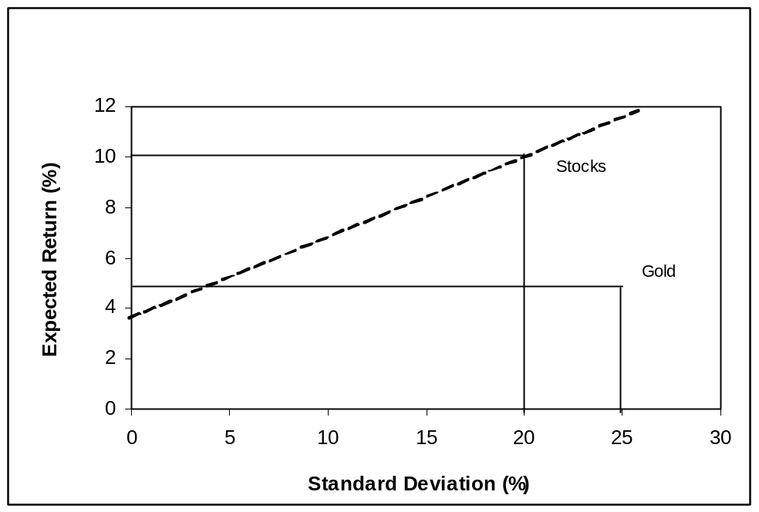

- Since Stock A and Stock B are perfectly negatively correlated, a risk-free portfolio can be created and the rate of return for this portfolio in equilibrium will always be the risk-free rate. To find the proportions of this portfolio [with w_{A} invested in Stock A and w_{B} = (1 – w_{A} ) invested in Stock B], set the standard deviation equal to zero. With perfect negative correlation, the portfolio standard deviation reduces to:
σ_{P} = Abs[w_{A}σ_{A} − w_{B}σ_{B}]
0 = 40 w_{A} − 60(1 – w_{A}) ⇒ w_{A} = 0.60
The expected rate of return on this risk-free portfolio is:
E(r) = (0.60 × 8%) + (0.40 × 13%) = 10.0%
Therefore, the risk-free rate must also be 10.0%.

- Since these are annual rates and the risk-free rate was quite variable during the sample period of the recent 20 years, the analysis has to be conducted with continuously compounded rates in excess of T-bill rates. Notice that to obtain cc rates we must convert percentage return to decimal. The decimal cc rate, ln(1+percentage rate/100), can then be multiplied by 100 to return to percentage rates. Recall also that with cc rates, excess returns are just the difference between total returns and the risk-free (T-bill) rates.

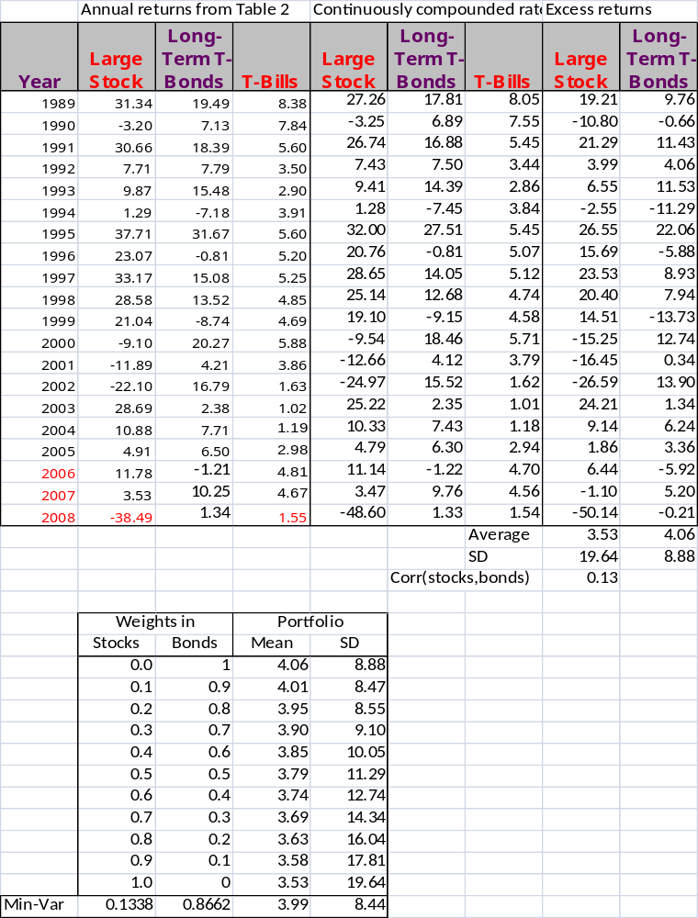
The bond portfolio is less risky as represented by its lower standard deviation. Yet, as the portfolio table shows, mixing 0.87% of bonds with 13% stocks would have produced a portfolio less risky than bonds. In this sample of these 20 years, the average return on the less risky portfolio of bonds was higher than that of the riskier portfolio of stocks. This is exactly what is meant by “risk.” Expectation will not always be realized.

- If the lending and borrowing rates are equal and there are no other constraints on portfolio choice, then optimal risky portfolios of all investors will be identical. However, if the borrowing and lending rates are not equal, then borrowers (who are relatively risk averse) and lenders (who are relatively risk tolerant) will have different optimal risky portfolios.

- No, it is not possible to get such a diagram. Even if the correlation between A and B were 1.0, the frontier would be a straight line connecting A and B.

- In the special case that all assets are perfectly positively correlated, the portfolio standard deviation is equal to the weighted average of the component-asset standard deviations. Otherwise, as the formula for portfolio variance (Equation 6.6) shows, the portfolio standard deviation is less than the weighted average of the component-asset standard deviations. The portfolio variance is a weighted sum of the elements in the covariance matrix, with the products of the portfolio proportions as weights.

- The probability distribution is:
Probability | Rate of Return
0.7 | 100%
0.3 | -50%
Expected return = (0.7 × 100%) + 0.3 × (−50%) = 55%
Variance = [0.7 × (100 − 55)2] + [0.3 × (−50 − 55)2] = 4725
Standard deviation =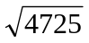= 68.74%

- The expected rate of return on the stock will change by beta times the unanticipated change in the market return: 1.2 × (8% – 10%) = – 2.4%
Therefore, the expected rate of return on the stock should be revised to:
12% – 2.4% = 9.6%

  - The risk of the diversified portfolio consists primarily of systematic risk. Beta measures systematic risk, which is the slope of the security characteristic line (SCL). The two figures depict the stocks' SCLs. Stock B's SCL is steeper, and hence Stock B's systematic risk is greater. The slope of the SCL, and hence the systematic risk, of Stock A is lower. Thus, for this investor, stock B is the riskiest.

  - The undiversified investor is exposed primarily to firm-specific risk. Stock A has higher firm-specific risk because the deviations of the observations from the SCL are larger for Stock A than for Stock B. Deviations are measured by the vertical distance of each observation from the SCL. Stock A is therefore riskiest to this investor.

- The answer will vary, depending on the data set selected. The following raw data is used to produce the subsequent results of 2.16. As with problem 15, excess returns are used in this computation.

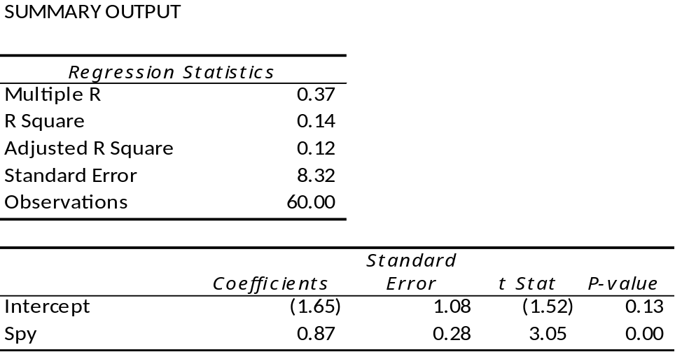

- A scatter plot results in the following diagram. The slope of the regression line is 2.0 and intercept is 1.0.
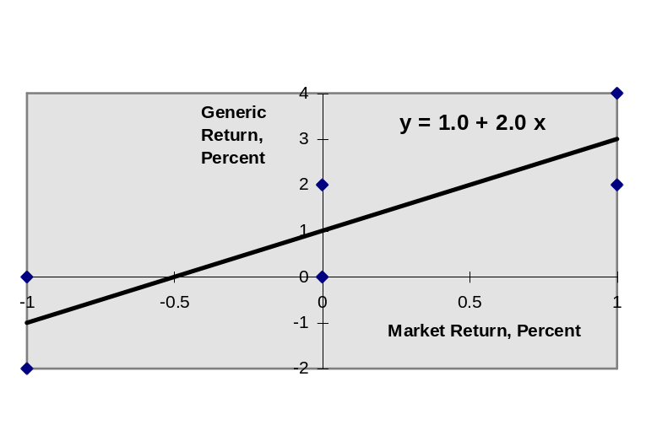

- Regression output produces the following.
a. alpha = 3.18, beta = 1.39, Residual St Dev = 12.78
b. Sharpe measure = -.61 / 4.03 = -0.15
c. Information ratio = 3.18 / 12.78 = .25
d. Wg = 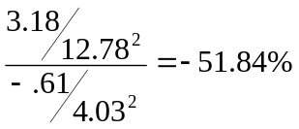

GOOG Weight = -.5184 / [1+(-51.84(1-1.39)] = - 2.04%
e. So = 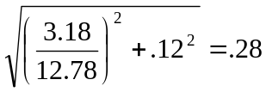…so sharpe increases from .12 to .28

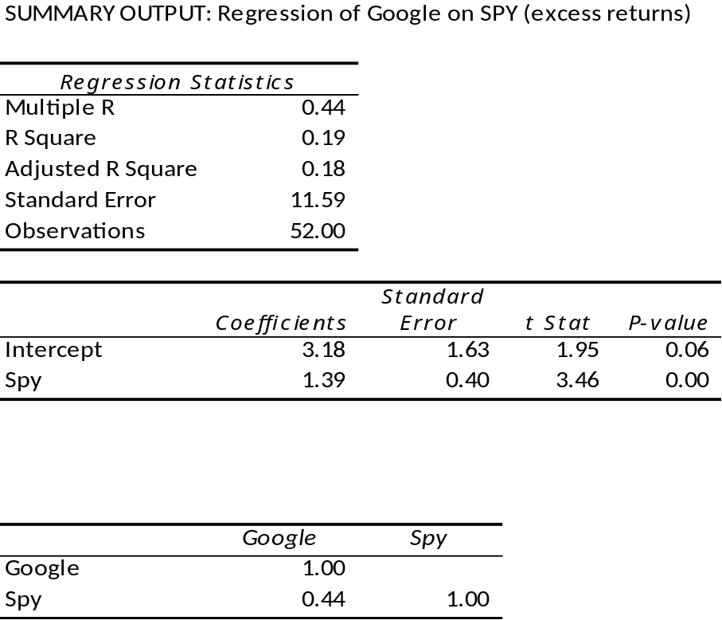

CFA 1
E(r_{P}) = (0.5 x 15) + (0.4 x 10) + (0.10 x 6) = 12.1%

CFA 2
Fund D represents the single best addition to complement Stephenson's current portfolio, given his selection criteria. First, Fund D’s expected return (14.0 percent) has the potential to increase the portfolio’s return somewhat. Second, Fund D’s relatively low correlation with his current portfolio (+0.65) indicates that Fund D will provide greater diversification benefits than any of the other alternatives except Fund B. The result of adding Fund D should be a portfolio with approximately the same expected return and somewhat lower volatility compared to the original portfolio.

The other three funds have shortcomings in terms of either expected return enhancement or volatility reduction through diversification benefits. Fund A offers the potential for increasing the portfolio’s return, but is too highly correlated to provide substantial volatility reduction benefits through diversification. Fund B provides substantial volatility reduction through diversification benefits, but is expected to generate a return well below the current portfolio’s return. Fund C has the greatest potential to increase the portfolio’s return, but is too highly correlated to provide substantial volatility reduction benefits through diversification.

CFA 3
  - Subscript OP refers to the original portfolio, ABC to the new stock, and NP to the new portfolio.
i. E(r_{NP}) = w_{OP} E(r_{OP} ) + w_{ABC} E(r_{ABC} ) = (0.9 × 0.67) + (0.1 × 1.25) = 0.728%
ii. Cov = r × σ_{OP} × σ_{ABC} = 0.40 × 2.37 × 2.95 = 2.7966 ≅ 2.80
iii. σ_{NP} = [w_{OP}² σ_{OP}² + w_{ABC}² σ_{ABC}² + 2 w_{OP} w_{ABC} (Cov_{OP , ABC})]^{1/2}
= [(0.9² × 2.37²) + (0.1² × 2.95²) + (2 × 0.9 × 0.1 × 2.80)]^{1/2}
= 2.2673% ≅ 2.27%

  - Subscript OP refers to the original portfolio, GS to government securities, and NP to the new portfolio.
i. E(r_{NP}) = w_{OP} E(r_{OP} ) + w_{GS} E(r_{GS} ) = (0.9 × 0.67) + (0.1 × 0.42) = 0.645%
ii. Cov = r × σ_{OP} × σ_{GS} = 0 × 2.37 × 0 = 0
iii. σ_{NP} = [w_{OP}² σ_{OP}² + w_{GS}² σ_{GS}² + 2 w_{OP} w_{GS} (Cov_{OP , GS})]^{1/2}
= [(0.9² × 2.37²) + (0.1² × 0) + (2 × 0.9 × 0.1 × 0)]^{1/2}
= 2.133% ≅ 2.13%

  - Adding the risk-free government securities would result in a lower beta for the new portfolio. The new portfolio beta will be a weighted average of the individual security betas in the portfolio; the presence of the risk-free securities would lower that weighted average.

  - The comment is not correct. Although the respective standard deviations and expected returns for the two securities under consideration are equal, the covariances between each security and the original portfolio are unknown, making it impossible to draw the conclusion stated. For instance, if the covariances are different, selecting one security over the other may result in a lower standard deviation for the portfolio as a whole. In such a case, that security would be the preferred investment, assuming all other factors are equal.

  - Grace clearly expressed the sentiment that the risk of loss was more important to her than the opportunity for return. Using variance (or standard deviation) as a measure of risk in her case has a serious limitation because standard deviation does not distinguish between positive and negative price movements.

CFA 4

- Restricting the portfolio to 20 stocks, rather than 40 to 50, will very likely increase the risk of the portfolio, due to the reduction in diversification. Such an increase might be acceptable if the expected return is increased sufficiently.

- Hennessy could contain the increase in risk by making sure that he maintains reasonable diversification among the 20 stocks that remain in his portfolio. This entails maintaining a low correlation among the remaining stocks. As a practical matter, this means that Hennessy would need to spread his portfolio among many industries, rather than concentrating in just a few.

CFA 5
Risk reduction benefits from diversification are not a linear function of the number of issues in the portfolio. (See Figures 6.1 and 6.2 in the text.) Rather, the incremental benefits from additional diversification are most important when the portfolio is least diversified. Restricting Hennessy to 10 issues, instead of 20 issues, would increase the risk of his portfolio by a greater amount than reducing the size of the portfolio from 30 to 20 stocks.

CFA 6
The point is well taken because the committee should be concerned with the volatility of the entire portfolio. Since Hennessy's portfolio is only one of six well-diversified portfolios, and is smaller than the average, the concentration in fewer issues might have a minimal effect on the diversification of the total fund. Hence, unleashing Hennessy to do stock picking may be advantageous.

CFA 7
- Systematic risk refers to fluctuations in asset prices caused by macroeconomic factors that are common to all risky assets; hence systematic risk is often referred to as market risk. Examples of systematic risk factors include the business cycle, inflation, monetary policy and technological changes.

Firm-specific risk refers to fluctuations in asset prices caused by factors that are independent of the market, such as industry characteristics or firm characteristics. Examples of firm-specific risk factors include litigation, patents, management, and financial leverage.

- Trudy should explain to the client that picking only the five best ideas would most likely result in the client holding a much more risky portfolio. The total risk of a portfolio, or portfolio variance, is the combination of systematic risk and firm-specific risk.

The systematic component depends on the sensitivity of the individual assets to market movements, as measured by beta. Assuming the portfolio is well-diversified, the number of assets will not affect the systematic risk component of portfolio variance. The portfolio beta depends on the individual security betas and the portfolio weights of those securities.

On the other hand, the components of firm-specific risk (sometimes called nonsystematic risk) are not perfectly positively correlated with each other and, as more assets are added to the portfolio, those additional assets tend to reduce portfolio risk. Hence, increasing the number of securities in a portfolio reduces firm-specific risk. For example, a patent expiration for one company would not affect the other securities in the portfolio. An increase in oil prices might hurt an airline stock but aid an energy stock. As the number of randomly selected securities increases, the total risk (variance) of the portfolio approaches its systematic variance.

